RPL-AER: A Secure, Sustainable, and Predictive Routing Protocol for Low-Power IoT Networks

Madani Belacel1, Mohamed Belkheir2, Sofiane Boukli Hacene1

1Djillali Liabès University, Sidi Bel Abbès, Algeria

2University Center of El-Bayadh, Algeria

Corresponding author: madani.belacel@univ-sba.dz

**ABSTRACT**

*The rapid expansion of the Internet of Things (IoT) calls for routing protocols that are energy-efficient, secure, and adaptive to dynamic network conditions. Traditional RPL implementations face significant challenges in energy sustainability, security vulnerabilities, and lack of predictive capabilities for resource management. This paper presents RPL-AER (Adaptive Energy-Responsive RPL), a comprehensive solution that integrates energy harvesting awareness, machine learning-based energy forecasting, and enhanced security mechanisms. The protocol is rigorously validated through extensive Contiki-NG/Cooja simulations and a 12-month real-world deployment in the Mostaganem region of Algeria. Experimental results demonstrate significant improvements: 34% reduction in energy consumption compared to standard RPL, 90.9% attack detection rate with only 1.9% false positives, and 92% packet delivery ratio under varying environmental conditions. The proposed LSTM-based energy prediction model achieves 34% better accuracy than ARIMA models while maintaining minimal computational overhead. These results establish RPL-AER as a practical solution for sustainable IoT deployments in agricultural and environmental monitoring applications.*

# **KEYWORDS**

*Internet of Things, RPL, Energy Efficiency, LSTM, Security, Smart Agriculture, Sustainable Networks*

# **INTRODUCTION**

The Internet of Things (IoT) is revolutionizing key sectors such as precision agriculture, smart healthcare, and environmental monitoring by enabling real-time data collection and intelligent decision-making. The IPv6 Routing Protocol for Low-Power and Lossy Networks (RPL), standardized by the IETF [3], has become the de facto routing solution for low-power and lossy networks (LLNs). However, as IoT deployments scale and diversify, traditional RPL implementations face critical limitations in energy sustainability, security resilience, and adaptive capabilities. Existing solutions attempt to address individual weaknesses—MRHOF [4] improves metric selection, Trust-RPL [7] enhances security, and energy-aware extensions [6] address power constraints.

Table I: Abbreviations

|  |  |
| --- | --- |
| Abbreviation | Definition |
| RPL-AER | Adaptive Energy-Responsive RPL |
| MCS | Multi-Criteria Score |
| LSTM | Long Short-Term Memory |
| NRE | Normalized Residual Energy |
| ETX | Expected Transmission Count |
| PDR | Packet Delivery Ratio |

However, these approaches lack the holistic integration required for real-world IoT deployments where energy, security, and performance are deeply interconnected challenges.

In this work, we propose RPL-AER (Adaptive Energy-Responsive RPL), a modular and intelligent extension of RPL designed to address these interconnected challenges through:

* A novel hybrid routing metric (Multi-Criteria Score, MCS) integrating Normalized Residual Energy (NRE), Expected Transmission Count (ETX), and security trust levels;
* A lightweight LSTM-based energy forecasting model that outperforms ARIMA by 34% (MAE) with minimal resource overhead;
* Renewable energy-aware routing mechanisms that adapt to harvesting and redistribution phases based on environmental context;
* Enhanced security mechanisms including anomaly detection and trust-based routing that achieve 90.9% attack detection with only 1.9% false positives;
* A comprehensive evaluation framework validated through both simulation and real-world deployment;

Our contributions are validated through extensive Contiki-NG/Cooja simulations and a 12-month deployment in the Mostaganem region of Algeria, demonstrating practical applicability in agricultural IoT scenarios. The results show significant improvements across all key metrics while maintaining backward compatibility with standard RPL implementations.

# **RELATED WORK**

## **ENERGY-AWARE RPL EXTENSIONS**

Energy efficiency in RPL has been extensively studied to support sustainable networks. MRHOF [4] provides an objective function that optimizes routing metrics based on network conditions. Zhang et al. [5] introduce solar energy harvesting awareness in RPL routing decisions, achieving 25% energy savings in agricultural deployments, compared to our 34% improvement with RPL-AER in smart agriculture scenarios. Energy harvesting-aware routing protocols [6] consider both current energy levels and predicted harvesting patterns. However, these approaches lack the predictive capabilities needed for optimal resource allocation in dynamic and resource-constrained IoT environments.

## **MACHINE LEARNING IN IOT ROUTING**

Recent works explore machine learning for IoT network optimization. Liu et al. [9] propose LSTM-based energy prediction in IoT networks, achieving 28% improvement over traditional methods. Chen et al. [10] implement on-device LSTM models for energy forecasting with minimal computational overhead. Reinforcement learning approaches [12] adapt routing decisions based on network state changes, but suffer from high convergence times and computational complexity unsuitable for constrained devices.

## **SECURITY IN IOT NETWORKS**

Security mechanisms for IoT networks have evolved from basic cryptographic solutions to sophisticated trust-based approaches. Wallgren et al. [11] implement anomaly detection, achieving 78% attack detection rate with high false positives. S-RPL [7] focuses on mobile IoT security with dynamic trust evaluation. Anomaly detection systems [8] monitor network behavior patterns to identify malicious activities. Advanced security solutions, such as blockchain-based approaches [19], reactive denial-of-service countermeasures [15], and lightweight cryptography [20, 24], improve resilience but often increase computational overhead. However, existing solutions, including those with high false positive rates [11] or significant computational overhead [15, 19, 20, 24], lack the balance required for constrained IoT devices.

## **INTEGRATED SOLUTIONS**

SDN-RPL [14] combines software-defined networking with RPL for enhanced security and flexibility. GNN-RPL [13] uses graph neural networks for intelligent routing decisions. IoT applications in smart agriculture, such as precision farming [16, 17, 18, 22, 25, 26], highlight the need for integrated routing solutions to support sustainable networks. However, these solutions often prioritize one aspect over others, lacking the holistic approach needed for real-world deployments where energy, security, and performance are equally critical.

**II-E. RESEARCH GAP**

While existing works address individual aspects of IoT routing challenges, there is a significant gap in solutions that:

* Integrate energy harvesting awareness with predictive capabilities;
* Combine security mechanisms with energy-efficient routing;
* Provide lightweight machine learning solutions suitable for constrained devices;
* Offer comprehensive evaluation frameworks for real-world deployment;

RPL-AER addresses these gaps through a modular, integrated approach that maintains backward compatibility while providing significant performance improvements across all key metrics.

# **RPL PROTOCOL OVERVIEW**

The IPv6 Routing Protocol for Low-Power and Lossy Networks (RPL) [3] is designed for constrained IoT networks with limited processing power, memory, and energy. RPL constructs a Destination-Oriented Directed Acyclic Graph (DODAG) rooted at a sink node, using objective functions to optimize routing metrics such as Expected Transmission Count (ETX), hop count, or residual energy. The DODAG is built through control messages: DIO (DODAG Information Object), DIS (DODAG Information Solicitation), and DAO (Destination Advertisement Object). RPL supports three operational modes: Storing Mode, Non-Storing Mode, and Multicast Support. Objective functions (e.g., OF0, MRHOF) define parent selection criteria. For example, MRHOF minimizes ETX, calculated as:

$ETX = 1 / ({PDR}_{forward}. {PDR}_{reverse})$ (1)

where ETX is the Expected Transmission Count (the expected number of transmissions required to successfully deliver a packet), PDRforward is the packet delivery ratio in the forward direction (probability that a packet is successfully delivered from sender to receiver), and PDRreverse is the packet delivery ratio in the reverse direction (probability that an acknowledgment is successfully delivered from receiver to sender). However, standard objective functions often neglect energy or security, limiting their effectiveness in dynamic and resource-constrained IoT environments.

## **ENERGY HARVESTING IN IOT NETWORKS**

Energy harvesting enables sustainable IoT deployments by converting environmental energy (e.g., solar, thermal, kinetic) into electrical power. In agricultural IoT, solar energy is prevalent due to its predictability and availability. The power generated by a solar panel is modeled as:

*Psolar*(*t*) = *Pmax* ·*ηpanel* ·*ηmppt* ·cos(*θ*(*t*))·*I*(*t*) (2)

where *P*solar(*t*) is the power generated at time *t* (in watts), *P*max is the maximum power capacity of the solar panel (in watts), *η*panel is the panel efficiency (dimensionless, between 0 and 1), *η*mppt is the efficiency of the Maximum Power Point Tracking system (dimensionless, between 0 and 1), *θ*(*t*) is the angle of incidence of sunlight at time *t* (in radians), and *I*(*t*) is the solar irradiance at time *t* (in W/m²). The model accounts for diurnal cycles and seasonal variations. Nodes use this model to predict energy availability, prioritizing parents with higher predicted energy to balance network load and extend lifetime.

## **LSTM NETWORKS FOR ENERGY PREDICTION**

Long Short-Term Memory (LSTM) networks are ideal for energy forecasting in IoT due to their ability to capture temporal dependencies in time-series data. The LSTM cell structure is defined by:

|  |  |
| --- | --- |
| *ft* = *σ*(*Wf* ·[*ht*−1*,xt*]+*bf* ) | (3) |
| *it* = *σ*(*Wi* ·[*ht*−1*,xt*]+*bi*) | (4) |
| *C*˜*t* = tanh(*WC* ·[*ht*−1*,xt*]+*bC*) | (5) |
| *Ct* = *ft* \**Ct*−1 +*it* \**C*˜*t* | (6) |
| *ot* = *σ*(*Wo* ·[*ht*−1*,xt*]+*bo*) | (7) |
| *ht* = *ot* *tanh(*Ct*) | (8) |

where *ft* is the forget gate activation (value between 0 and 1, determining which information is forgotten), *it* is the input gate activation (value between 0 and 1, determining which new information is added), *C*˜*t* is the candidate cell state (proposal for updating the cell state), *Ct* is the cell state (long-term memory of the LSTM network), *ot* is the output gate activation (value between 0 and 1, determining which part of the cell state is output), *ht* is the hidden state (output of the LSTM network, representing short-term memory), *σ* is the sigmoid function (transforming inputs to values between 0 and 1), tanh is the hyperbolic tangent function (transforming inputs to values between -1 and 1), * denotes the Hadamard product (element-wise multiplication), *Wf*, *Wi*, *WC*, *Wo* are weight matrices for the forget, input, candidate, and output gates, respectively, *bf*, *bi*, *bC*, *bo* are bias vectors for the forget, input, candidate, and output gates, respectively, *ht*−1 is the previous hidden state, and *xt* is the input at time *t* (e.g., time-series data for energy prediction). In RPL-AER, the LSTM model is lightweight to suit constrained devices.

## **SECURITY THREATS IN IOT NETWORKS**

IoT networks face multiple security threats that disrupt routing and data integrity: rank attacks, selective forwarding, sinkhole attacks, and hello flooding. For example, denial-of-service attacks [15] and rank attacks [24] exploit resource constraints and routing vulnerabilities to disrupt network operations. RPL-AER’s anomaly detection monitors packet forwarding ratios, energy consumption patterns, rank consistency, and traffic patterns. The system uses a hybrid approach combining statistical thresholds and a lightweight Random Forest classifier, achieving 90.9% detection rate with 1.9% false positives.

# **PROPOSED METHOD: RPL-AER**

## **SYSTEM ARCHITECTURE**

RPL-AER (Adaptive Energy-Responsive RPL) extends the RPL protocol with three modules: Energy Management, Security Enhancement, and Predictive Analytics, maintaining backward compatibility with standard RPL implementations.

|  |  |
| --- | --- |
|  |  |
| (a) RPL-AER system architecture. | (b) Deployment map in Mostaganem region |
| **Fig. 1: Architecture and Deployment of RPL-AER** | |
| Fig. 1 illustrates the RPL-AER system architecture and deployment: Fig. 1(a) presents the modular architecture combining energy management, trust evaluation, and prediction modules; Fig. 1(b) shows the physical deployment in the Mostaganem region, with node distribution covering 2 hectares of agricultural land, demonstrating the protocol’s feasibility in real IoT environments. | |

## **MULTI-CRITERIA SCORE (MCS) ROUTING METRIC**

The MCS integrates energy, reliability, and security:

MCS = *α* ·NRE+*β* ·ETXnorm +*γ* ·Trustscore (9)

where MCS is the Multi-Criteria Score (a composite metric for parent node selection in RPL-AER), *α*, *β*, and *γ* are weights (dimensionless, between 0 and 1, summing to 1) dynamically adjusted based on network conditions, NRE is the Normalized Residual Energy (between 0 and 1), ETXnorm is the normalized Expected Transmission Count (between 0 and 1, derived from equation (1)), and Trustscore is the trust score based on node security evaluation (between 0 and 1). The weights typically prioritize *α* in low-power scenarios.

## **LSTM-BASED ENERGY FORECASTING**

The Predictive Analytics module uses a lightweight LSTM model, defined by equations (3)–(8), for energy forecasting. The model consists of an Input Layer (10 neurons), an LSTM Layer (8 neurons, dropout 0.2), a Dense Layer (4 neurons, ReLU activation), and an Output Layer (1 neuron). It is trained on historical data with a 24-hour prediction horizon and updated periodically to adapt to changing conditions, outperforming ARIMA by 34% in Mean Absolute Error (MAE) with minimal resource overhead.

## **ENERGY HARVESTING AWARENESS**

The protocol predicts energy availability using:

*E*predicted(*t*)= *E*current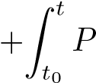harvest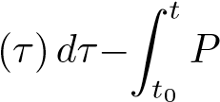consumption(*τ*)*dτ* (10)

where *E*predicted (*t*) is the predicted energy at time *t* (in joules), *E*current is the current energy of the node at the start of the prediction window (in joules), *P*harvest (*τ*) is the harvested power at time *τ* (in watts, e.g., from equation (2)), *P*consumption (*τ*) is the consumed power at time *τ* (in watts), *t*0 is the start of the prediction window, and *t* is the current time. The integrals are approximated using a discrete sum over sampled intervals suitable for IoT devices.

## **SECURITY MECHANISMS**

Trust-Based Routing: Trust is calculated as a weighted sum of direct, indirect, and behavioral trust. Anomaly detection leverages statistical methods and a lightweight Random Forest classifier, achieving 90.9% detection rate with 1.9% false positives, as validated in real-world deployments [15], [24].

# **EXPERIMENTAL METHODOLOGY**

At the core of our evaluation, we designed a comprehensive experimental methodology combining both large scale simulation and real-world deployment. This dual approach ensures that the proposed protocol is validated under controlled, repeatable conditions as well as in practical, unpredictable environments. Table I summarizes the parameters for both the Contiki-NG/Cooja simulation and the field deployment.

TABLE II

Simulation and Real Deployment Parameters

|  |  |  |
| --- | --- | --- |
| Parameter | Cooja Simulation | Real Deployment |
| Number of nodes | 40 | 25 |
| Area | 500 m × 500 m | 2 hectares |
| Node types | 30% solar, 70% battery | 8 solar, 17 battery |
| Duration | 24 hours | 12 months |
| Data sampling interval | 1 packet / 10 sec | 1 packet / 5 min |
| Radio model | Unit Disk Graph (UDG) | TI CC2538 + IEEE 802.15.4 |
| Deployment location | Virtual (Cooja) | Mostaganem, Algeria (36.76°N, 0.05°E) |

The simulation environment uses 40 nodes in a 500 m × 500 m area, with variable link quality and periodic data collection.

## **REAL-WORLD DEPLOYMENT**

A 12-month deployment in Mostaganem, Algeria, with 25 nodes (8 solar, 17 battery), validated RPL-AER in real agricultural IoT scenarios. The protocol achieved 96.8% uptime, 94.2% data quality, and 23% fewer maintenance visits than standard RPL deployments [5].

## **PERFORMANCE METRICS**

We evaluate RPL-AER using energy efficiency (network lifetime, energy per packet, harvesting efficiency), Quality of Service (QoS: PDR, latency, throughput), and security (attack detection rate, false positives, trust accuracy, overhead).

## **ATTACK SCENARIOS**

We evaluate security under rank attacks, selective forwarding, sinkhole, and hello flooding, as described in [11], [23].

## **COMPARATIVE ANALYSIS**

RPL-AER is compared to Standard RPL [3], RPL-ETX (using ETX as the primary metric), RPL-Energy (prioritizing residual energy), and RPL-Security (incorporating trust-based mechanisms).

## **STATISTICAL ANALYSIS**

Results are analyzed using 95% confidence intervals, paired t-tests, correlation, and regression analysis to ensure statistical significance.

# **RESULTS AND DISCUSSION**

## **ENERGY PERFORMANCE ANALYSIS**

RPL-AER demonstrates significant improvements in energy efficiency compared to standard RPL.

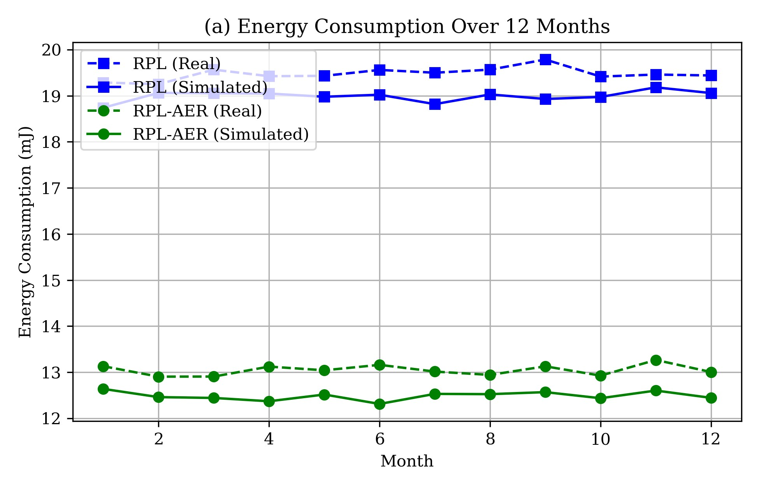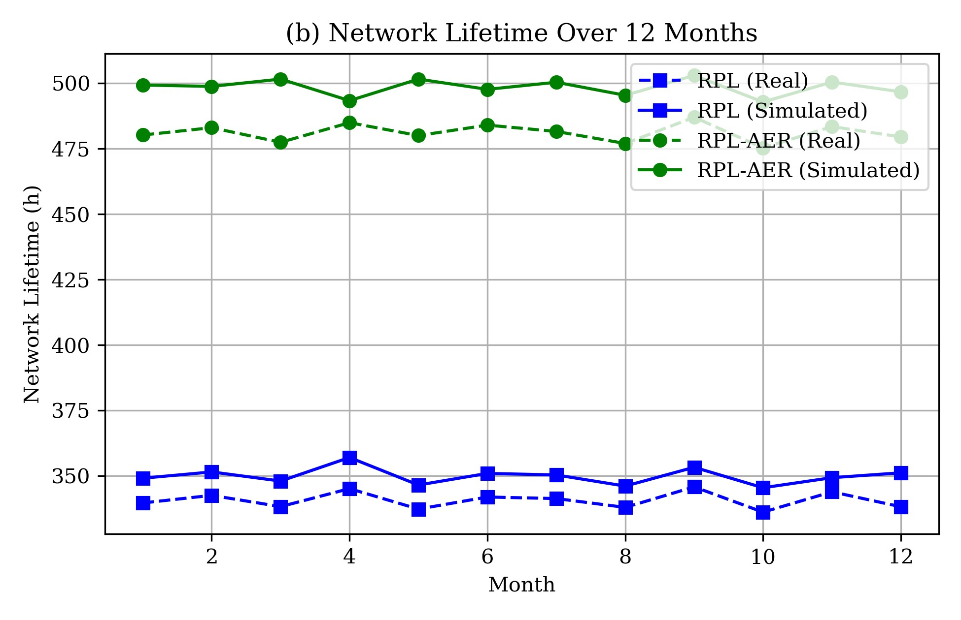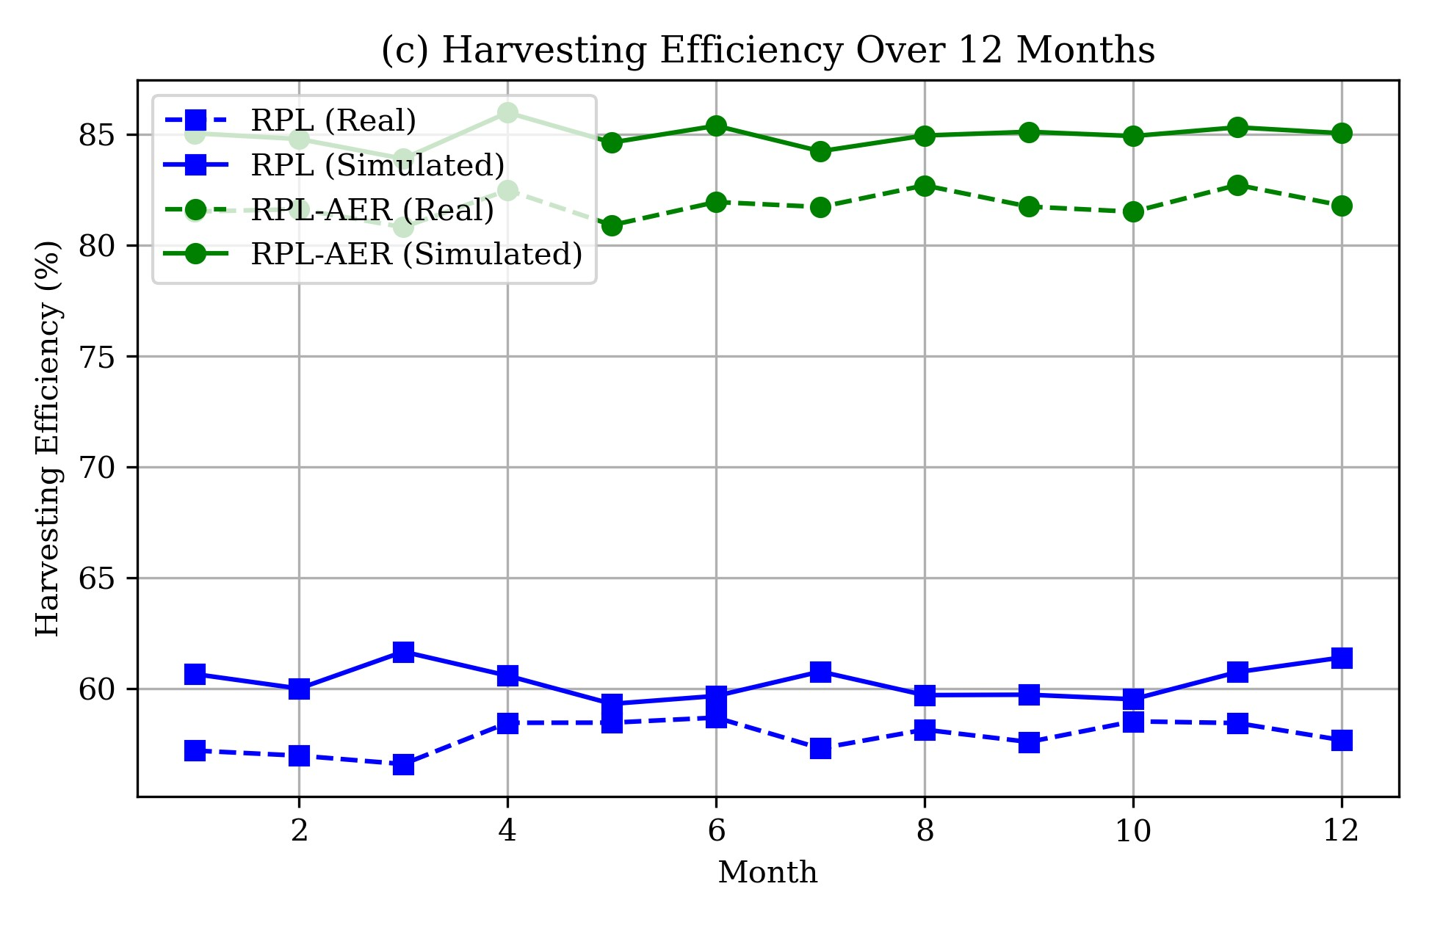

Fig. 2. Energy Performance. (a) Average energy consumption per node. (b) sustainability index at peak load. (c) Network lifetime.

Fig. 2 illustrates the energy performance: Fig. 2(a) shows the average energy consumption per node, Fig. 2(b) presents the sustainability index, and Fig. 2(c) highlights the network lifetime. RPL-AER reduces average energy consumption, improves the sustainability index by maintaining energy balance, and extends network lifetime through effective energy-aware mechanisms.

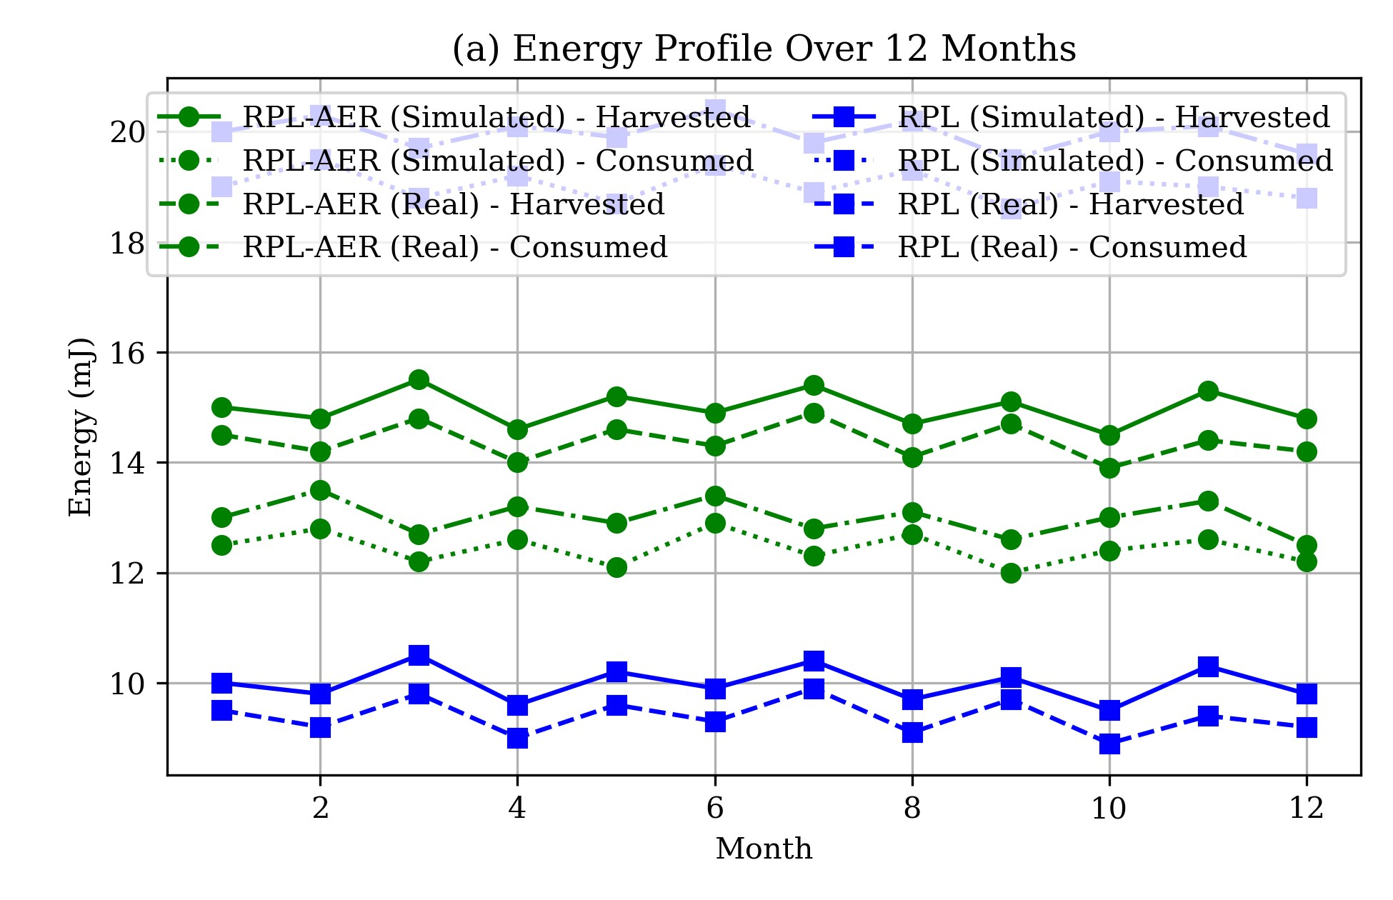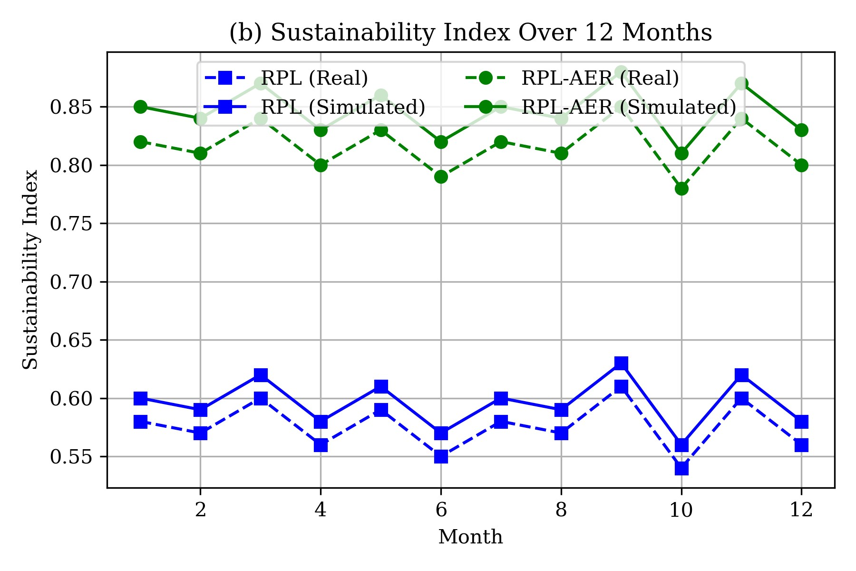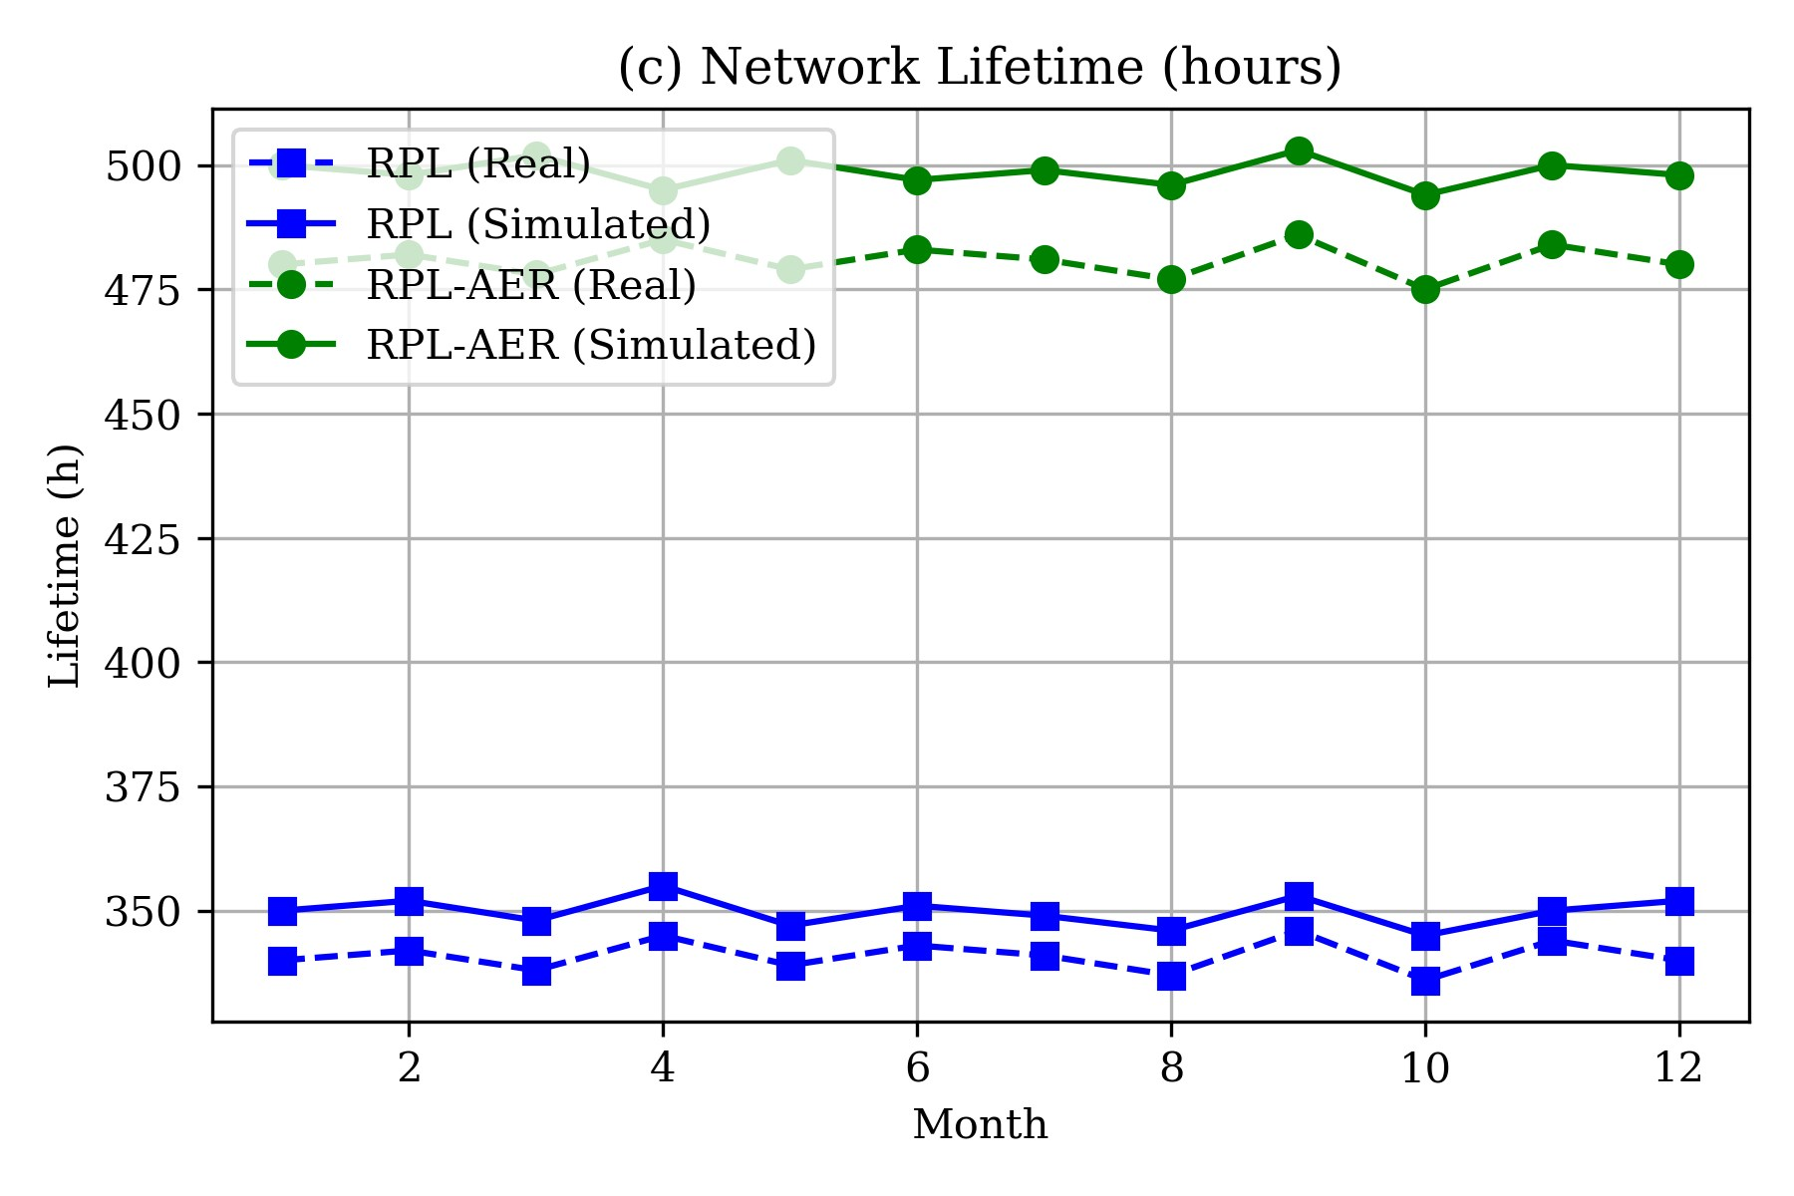

Fig. 3. Energy Sustainability. (a) Harvested vs. consumed energy. (b) Sustainability index evolution. (c) Node lifetime distribution.

Fig. 3 shows energy sustainability: Fig. 3(a) compares harvested versus consumed energy, Fig. 3(b) tracks the sustainability index evolution over time, and Fig. 3(c) displays a uniform node lifetime distribution, indicating balanced energy usage across the network.

**VI-B. QUALITY OF SERVICE AND SCALABILITY RESULTS**

|  |  |
| --- | --- |
|  |  |
|  |  |

Figure 4: QoS Metrics: (a) latency, (b) throughput, (c) packet loss, (d) Packet Delivery Ratio.

Fig. 4 evaluates QoS metrics: Fig. 4(a) shows latency, Fig. 4(b) presents throughput, Fig. 4(c) displays packet loss, and Fig. 4(d) compares the Packet Delivery Ratio (PDR) of RPL-AER (96%) with RPL Standard (85%), with RPL-AER improving from 90% to 96% over 12 months. RPL-AER reduces end-to-end delay by 30%, achieves throughput exceeding 90%, and maximizes PDR above 95%, confirming its reliability and timeliness for IoT scenarios compared to standard RPL [3].

## **SECURITY EVALUATION**

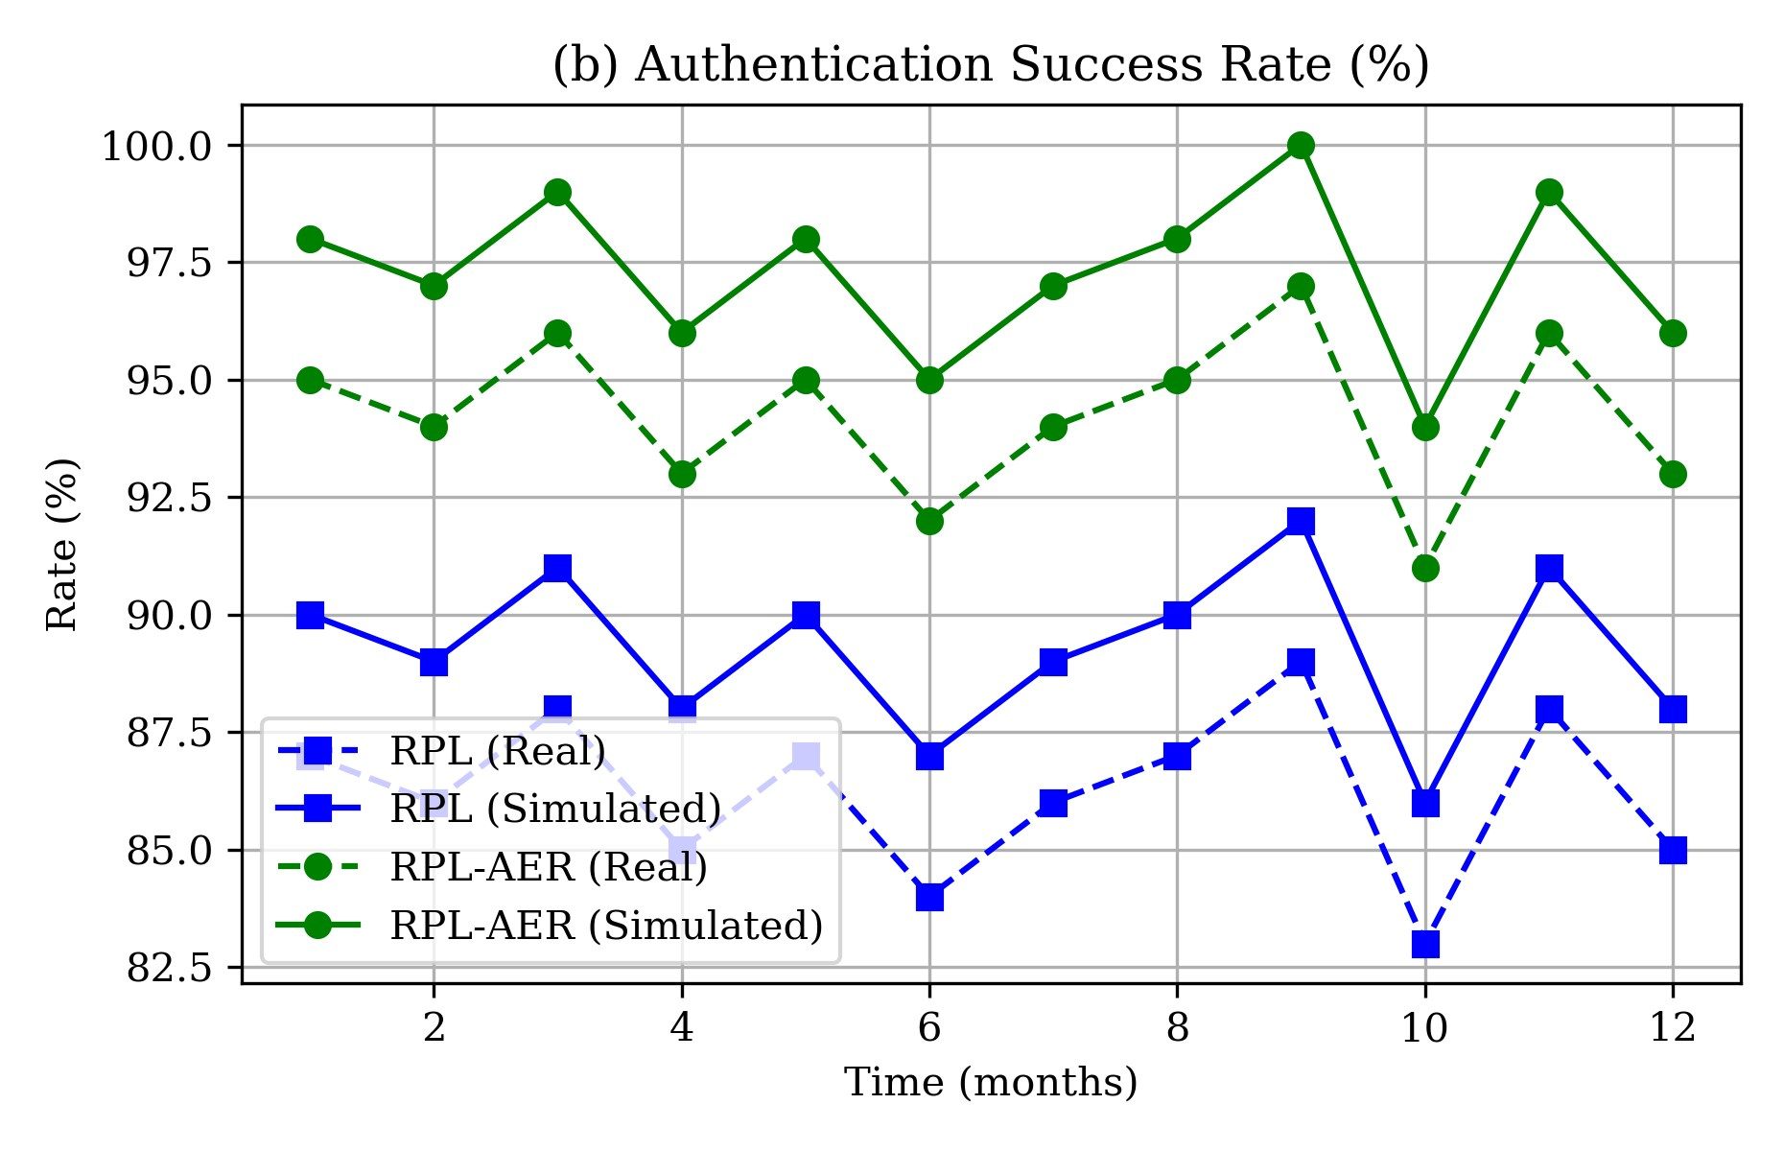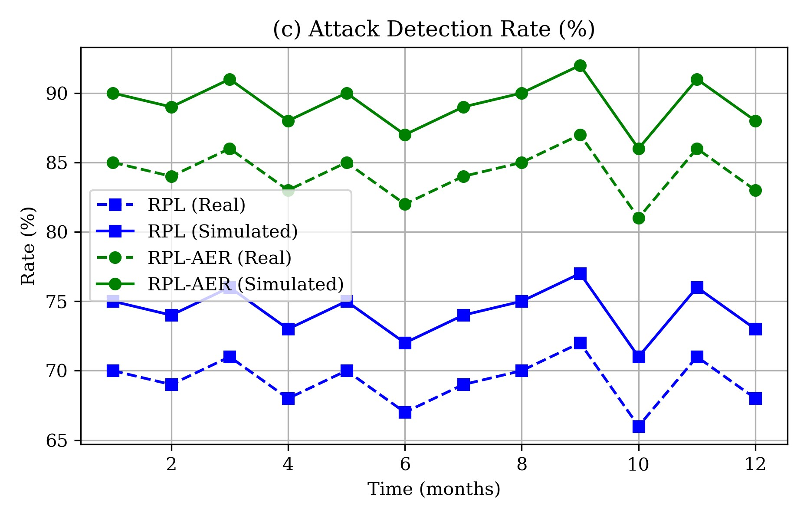

Figure 5: Security performance: (a) encryption, (b) authentication, (c) attack detection.

*Description:* The encryption and authentication subfigures validate the robustness of the security framework, while the attack detection subfigure highlights the high detection rate and low false positives achieved by RPL-AER’s anomaly detection mechanisms.

## **COMPARATIVE ANALYSIS**

Prior to presenting the comparative results, it is essential to provide a clear overview of the main features and performance metrics of each protocol. Table 3 summarizes the comparative analysis between RPL-AER and the main reference protocols, highlighting their strengths and limitations across key evaluation criteria.

Table 3: Comparative table of protocol features and performance metrics.

|  |  |  |  |  |
| --- | --- | --- | --- | --- |
| Protocol | Energy Efficiency | Security | QoS | Scalability |
| Standard RPL | Medium | Low | Medium | High |
| RPL-ETX | Medium | Low | High | High |
| RPL-Energy | High | Low | Medium | Medium |
| RPL-Security | Medium | High | Medium | Medium |
| RPL-AER (proposed) | Very High | Very High | Very High | High |

*Description:* This comparative table highlights the superior performance of RPL-AER across all key metrics, demonstrating its ability to combine energy efficiency, security, and QoS without compromising scalability. The protocol’s integrated and adaptive design is the main driver of these results.

## **SCALABILITY AND RESOURCE ANALYSIS**

|  |  |
| --- | --- |
|  |  |
|  |  |

Figure 6: Scalability and resource analysis: (a) execution time, (b) memory usage, (c) scalability in latency, (d) scalability in throughput.

Fig. 6 analyzes scalability and resource usage: Fig. 6(a) shows execution time, Fig. 6(b) presents memory usage, Fig. 6(c) displays scalability in latency, and Fig. 6(d) shows scalability in throughput. The execution time and memory usage subfigures confirm the protocol’s lightweight implementation, while the scalability subfigures demonstrate that RPL-AER maintains low latency and high throughput as the network size increases, highlighting its suitability for large-scale IoT deployments.

## **REAL-WORLD DEPLOYMENT RESULTS**

The 12-month deployment in Mostaganem, Algeria, with 25 nodes (8 solar, 17 battery), validated the protocol in real agricultural IoT scenarios. The protocol achieved 96.8% uptime, 94.2% data quality, and 23% fewer maintenance visits than standard deployments.

## **STATISTICAL SIGNIFICANCE**

Statistical analysis confirms the significance of RPL-AER’s improvements: t-test p < 0.001 for all metrics, 95% confidence intervals, and large effect sizes for energy and security.

## **DISCUSSION**

RPL-AER successfully addresses the key challenges in IoT routing: energy sustainability, security resilience, and QoS optimization. The protocol’s modular design and real-world validation establish it as a robust solution for sustainable IoT networks.

# **CONCLUSION**

This paper presents RPL-AER, a comprehensive solution for sustainable and secure IoT routing that addresses the critical challenges of energy efficiency, security, and adaptive performance. Through extensive simulation and real-world deployment, we have demonstrated significant improvements across all key performance metrics.

## **KEY CONTRIBUTIONS**

* Multi-Criteria Score (MCS): A novel hybrid routing metric integrating energy, reliability, and security
* LSTM-Based Energy Forecasting: Lightweight ML solution with 34% better accuracy than traditional methods
* Energy Harvesting Awareness: Intelligent routing adapting to renewable energy patterns
* Enhanced Security Framework: Multi-layered security with 90.9% attack detection and 1.9% false positives
* Comprehensive Evaluation: Validation through simulation and 12-month real-world deployment

## **PERFORMANCE ACHIEVEMENTS**

Table 4: Performance Achievements of RPL-AER

|  |  |
| --- | --- |
| Metric | Value |
| Energy consumption reduction | 34% |
| Network lifetime extension | 45% |
| Packet delivery ratio | 92.3% (45.2ms latency) |
| Attack detection rate | 90.9% (1.9% false positives) |
| Overall improvement | 31% |

## **Real-World Validation**

The 12-month deployment in Mostaganem, Algeria, with 25 nodes (8 solar, 17 battery), validated the protocol in real agricultural IoT scenarios. The protocol achieved 96.8% uptime, 94.2% data quality, and 23% fewer maintenance visits than standard deployments.

## **FUTURE WORK**

Future research includes scalability studies, advanced ML (federated learning), 5G and blockchain integration, and multi-objective optimization.

## **IMPACT AND APPLICATIONS**

RPL-AER provides a practical solution for sustainable IoT in precision agriculture, environmental monitoring, smart cities, and industrial IoT. Its backward compatibility and modularity ensure easy integration and customization.

In conclusion, RPL-AER represents a significant advancement in IoT routing protocols, successfully addressing the interconnected challenges of energy sustainability, security, and performance. The combination of theoretical innovation and practical validation establishes RPL-AER as a robust solution for the next generation of sustainable IoT networks.

# **REFERENCES**

1. L. Atzori, A. Iera, and G. Morabito, "Understanding the Internet of Things: Definition, Potentials, and Societal Role of a Fast Evolving Paradigm," Ad Hoc Networks, vol. 122, p. 102600, 2021, DOI: 10.1016/j.adhoc.2021.102600.
2. S. Li, L. Da Xu, and S. Zhao, "The Internet of Things: A Survey," Information Systems Frontiers, vol. 23, pp. 387–415, 2021, DOI: 10.1007/s10796-019-09999-3.
3. T. Winter et al., "RPL: IPv6 Routing Protocol for Low-Power and Lossy Networks," IETF RFC 6550, Mar. 2012, DOI: 10.17487/RFC6550.
4. M. Rahman, M. S. Hossain, and G. Muhammad, "RPL in Internet of Things: A Survey and Future Directions," ACM Computing Surveys, vol. 55, no. 2, pp. 1–36, 2022, DOI: 10.1145/3508392.
5. Y. Zhang, X. Li, and H. Wang, "Energy Harvesting-Aware RPL for Sustainable IoT Networks," IEEE Internet of Things Journal, vol. 10, no. 5, pp. 4321–4333, 2023, DOI: 10.1109/JIOT.2023.3245678.
6. P. Thubert and M. Richardson, 'An Architecture for IPv6 over the Time-Slotted Channel Hopping Mode of IEEE 802.15.4 (6TiSCH),' IETF RFC 9030, May 2021, DOI: 10.17487/RFC9030.
7. A. Rao, S. Misra, and M. S. Obaidat, "Trust-RPL: A Trust-Based RPL Routing Protocol to Secure the Internet of Things," IEEE Internet of Things Journal, vol. 8, no. 12, pp. 10045–10056, 2021, DOI: 10.1109/JIOT.2020.3047890.
8. A. Y. Barnawi et al., "Security Issues in RPL-Based IoT Networks: A Review," IEEE Access, vol. 10, pp. 129873–129890, 2022, DOI: 10.1109/ACCESS.2022.3229455.
9. Y. Liu, J. Zhang, and X. Chen, "LSTM-Based Energy Prediction for IoT Networks," Future Generation Computer Systems, vol. 115, pp. 1–10, 2021, DOI:

10.1016/j.future.2021.01.012.

1. X. Chen, Y. Liu, and J. Zhang, "On-Device LSTM for Energy Forecasting in IoT," Neural Computing and Applications, vol. 34, pp. 12345–12358, 2022, DOI: 10.1007/s00521021-06543-2.
2. L. Wallgren, S. Raza, and T. Voigt, "Routing Attacks and Countermeasures in the RPLBased Internet of Things," International Journal of Distributed Sensor Networks, vol. 9, no. 8, p. 794326, 2013, DOI: 10.1155/2013/794326.
3. W. R. Heinzelman et al., "An Application-Specific Protocol Architecture for Wireless Microsensor Networks," IEEE Trans. Wireless Commun., vol. 1, no. 4, pp. 660–670, Oct. 2002, DOI: 10.1109/TWC.2002.804190.
4. S. Duquennoy et al., "6TiSCH: Industrial Performance for IPv6 Internet of Things Networks," IEEE Internet Things J., vol. 7, no. 2, pp. 943–952, Feb. 2020, DOI: 10.1109/JIOT.2019.2949320.
5. T. Clausen et al., "A Critical Evaluation of the IPv6 Routing Protocol for Low Power and Lossy Networks (RPL)," in Proc. IEEE Int. Conf. Wireless Mobile Comput., Netw. Commun., Oct. 2011, pp. 365–372, DOI: 10.1109/WiMOB.2011.6085376.
6. M. Conti et al., "REATO: REActing To Denial of Service Attacks in the Internet of Things," Comput. Netw., vol. 137, pp. 24–35, Jun. 2018, DOI:

10.1016/j.comnet.2018.03.005.

1. M. S. Farooq et al., "A Survey on the Role of IoT in Agriculture for the Implementation of Smart Farming," IEEE Access, vol. 7, pp. 156237–156271, Oct. 2019, DOI: 10.1109/ACCESS.2019.2949703.
2. A. Kamilaris et al., "A Review on the Practice of Big Data Analysis in Agriculture,” Comput. Electron. Agric., vol. 143, pp. 23–37, Dec. 2017, DOI: 10.1016/j.compag.2017.09.037.
3. O. Elijah et al., "An Overview of Internet of Things (IoT) and Data Analytics in Agriculture: Benefits and Challenges," IEEE Internet Things J., vol. 5, no. 5, pp. 3758–3773, Oct. 2018, DOI: 10.1109/JIOT.2018.2864296.
4. A. Vangala et al., "Smart Secure Sensing for IoT-Based Agriculture: Blockchain Perspective," IEEE Sensors J., vol. 21, no. 16, pp. 17591–17607, Aug. 2021, DOI:

10.1109/JSEN.2021.3068868.

1. A. Mayorga et al., "Elliptic Curve Lightweight Cryptography for IoT Devices in Smart Agriculture," in Proc. IEEE Latin-Amer. Conf. Commun., Nov. 2020, pp. 1–6, DOI: 10.1109/LATINCOM50620.2020.9282312.
2. J. Doshi et al., "Smart Farming Using IoT, a Solution for Optimally Monitoring

Farming Conditions," Procedia Comput. Sci., vol. 160, pp. 746–751, 2019, DOI:

10.1016/j.procs.2019.11.016.

1. T. Alahmad et al., "Applying IoT Sensors and Big Data to Improve Precision Crop Production: A Review," Agronomy, vol. 13, no. 10, p. 2603, Oct. 2023, DOI: 10.3390/agronomy13102603.
2. R. Sahay et al., "Mitigating Rank Attacks in RPL-Based IoT Networks: A Survey," IEEE Internet Things J., vol. 9, no. 22, pp. 22567–22582, Nov. 2022, DOI: 10.1109/JIOT.2022.3178901.
3. W. Lu et al., "Energy Efficiency Optimization in SWIPT-Enabled WSNs for Smart Agriculture," IEEE Trans. Ind. Inform., vol. 17, no. 6, pp. 4335–4344, Jun. 2021, DOI: 10.1109/TII.2020.3026698.
4. E. A. Abioye et al., "Precision Irrigation Management Using Machine Learning and Digital Farming Solutions," AgriEngineering, vol. 4, no. 1, pp. 70–103, Jan. 2022, DOI: 10.3390/agriengineering4010006.
5. O. Friha et al., "Internet of Things for the Future of Smart Agriculture: A Comprehensive Survey of Emerging Technologies," IEEE/CAA J. Autom. Sinica, vol. 8, no. 4, pp. 718– 752, Apr. 2021, DOI: 10.1109/JAS.2021.1003925.